1) Local Admin Credentials:
Username: Admin or Administrator
Password:
1) MSCFO: msCFO@Numera#2025
2) MTF: MTF@Numera#2025
If both passwords will not work try this password: MSCFO@2018#
Note: for MSCFO User if MSCFO password does not work, please try using the MTF password. Similarly, for the MTF user, if the MTF password does not work, you may try using the MSCFO password.
2) M365 Account Credentials:
Admin Accounts:
admin@mytaxfiler11.onmicrosoft.com
Password: Numera@2025
admin@mystartup11.onmicrosoft.com
Password: Numera@2025
User account:
For MTF User: Mtf#1234
For MSCFO User: Cfo#1234
Note: We are not sharing M365 accounts password with the Users.
3) Nitro pro license:
NP8D8FXKOXO61ACB378
Process:
Open Nitro Pro application – Go to Help – About Nitro Pro – Serial Number
Name: User Full name
Company: Numera
Serial Number: NP8D8FXKOXO61ACB378
4) CrowdStrike:
Download and install the File on User laptop,
Next Enter Admin account password,
After that it will prompt for CID number : E8AA03F06DFB4844BEDA28D0F6A9CE91-F9
Next click on Install.
After installation change the Hostname:
Hostname: Entity-Emp ID
Ex: MSCFO-1001
Ex: MTF-1001
You will find these details in Google sheet
5) All the tools have been shared in the Teams group. (The setup file has been shared with the Team
MSCFO Tools (MystartupCFO)
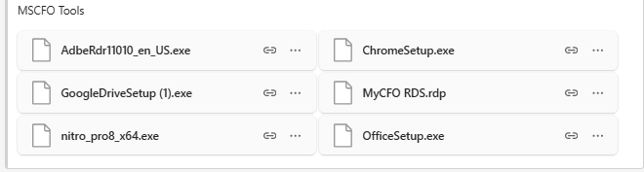
MTF Tools (MyTaxfiler)
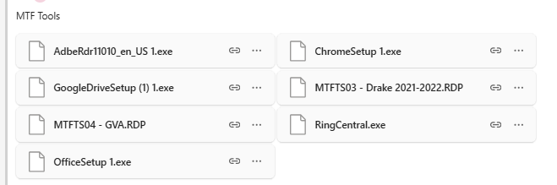
CrowdStrike Falcon Sensor:
